Which of the following is a new element in HTML5?

|  |
| --- |
| body |
| legend |
| embed |
| datalist |

You want to start drawing on a Canvas element to draw several arcs and then fill the area with a solid blue colour. Which piece of code would you call first?

|  |
| --- |
| var context = canvas.getContext('2d'); |
| context.fillStyle = '#8ED6FF'; |
| context.fill(); |
| var canvas = document.getElementById('myCanvas'); |

Which of the following HTML elements would you use to define a group of media and a caption?

|  |
| --- |
| span |
| object |
| img |
| figure |

One of your prestige clients wants you to redesign their financial website so that it uses CSS stylesheets to improve the layout for mobile devices. You need to understand the order of priority that CSS styles are applied, do you know which one of the following takes precedence over the rest?

|  |
| --- |
| internal style sheet |
| browser default |
| external style sheet |
| inline style |

You’re trying to add 10 spaces to a paragraph but the rendered page is always displaying a single space? What is the best way to fix this?

|  |
| --- |
| Use &nbsp;for the extra spaces |
| Wrap this sentence in an <em> tag |
| Use a textbox to display the sentence instead |
| Wrap the spaces in a DIV tag first |

In Javascript you can use the addEventListender() function to attach to an event and execute additional code when an action occurs. Do you know what the two required arguments are to the addEventListerner() method?

|  |
| --- |
| Element and function |
| Event and function |
| Element and async |
| Function and async |

You’re using the new Canvas element to draw graphics on your web page. You want to draw a line from the top left hand corner to the opposite bottom hand corner.   
  
Which piece of code would you use first?

|  |
| --- |
| context.moveTo(0,0) |
| context.stroke() |
| context.lineTo(300,300) |
| context.beginPath() |
|  |

One of the developers on your team is asking some tricky questions to test the teams knowledge of CSS styles. He asks you which of the following has the highest priority when determining which CSS style to apply?

|  |
| --- |
| element |
| #id |
| They are all the same priority |
| .class |

You’re working on a new web page for a local school. The page displays text in different font types, sizes and styles. One particular paragraph needs to be in italic. You’ve decided to make the text italic using CSS styles. Which property should you use to change the text to italic?

|  |
| --- |
| font-weight |
| font-style |
| font-family |
| font-variant |

You need to create an HTML table to display summary information for an online checkout page. This table will display all the products that the visitor has added to their basket, in addition to a total price for all the items.   
  
Which of the following HTML tags is not a valid child item for the table element?

|  |
| --- |
| tr |
| tf |
| td |
| th |

Question 13 o

f 15

Is the following Javascript statement TRUE or FALSE?  
  
”56” === 56

|  |
| --- |
| TRUE |
| FALSE |

An HTML page has a canvas element.  
You need to draw a red rectangle on the canvas element dynamically. The rectangle  
should resemble the following graphic.  
  
How should you build the code segment? (To answer, select the appropriate options from  
the drop-down lists in the answer area.)

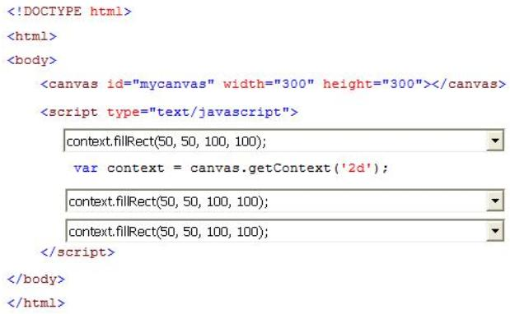

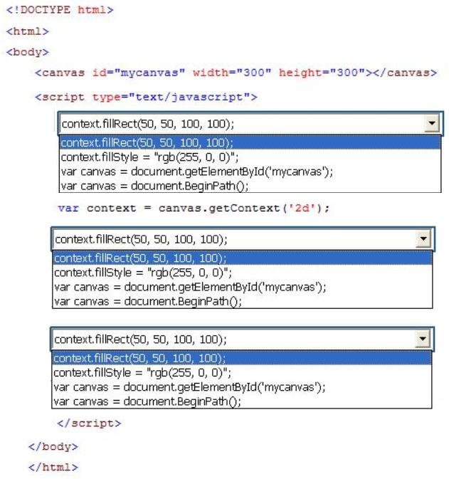

You are creating a JavaScript function that displays the name of a web application.  
You declare the following button element.  
<input type="button" id= "About" value="About" />  
When a user clicks the button, a JavaScript function named About must be called.  
You need to create an event handler that calls the About function when the button is  
clicked.  
Which two code segments can you use? (Each correct answer presents a complete  
solution. Choose two.)

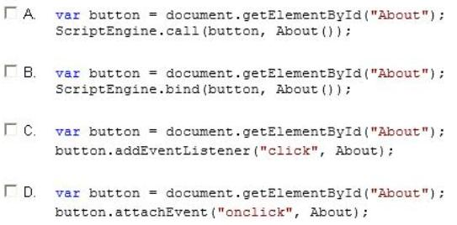

You need to test the value of the following variable in JavaScript.  
var length = "75";  
A block of code must execute if the length equals 75 regardless of the data type.  
You need to use the statement that meets this requirement.  
Which lines of code should you use? (Each correct answer presents a complete solution.  
Choose two.)

**A.** if (length = = = 75)  
**B.** if (length = = 75)  
**C.** if (length! = 75)  
**D.** if (length = = "75")

You are modifying an existing web page. The page is being optimized for accessibility. The  
current page contains the following HTML.  
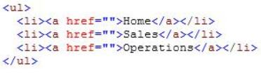  
Standards-compliant screen readers must be able to identify the links contained within the  
navigation structure automatically.  
You need to create the navigation link structure in the page.  
With which container tags should you wrap the existing markup?

**A.** <navmap> </navmap>  
**B.** <div id="nav"> </div>  
**C.**  <nav> </nav>  
**D.**  <map> </map>

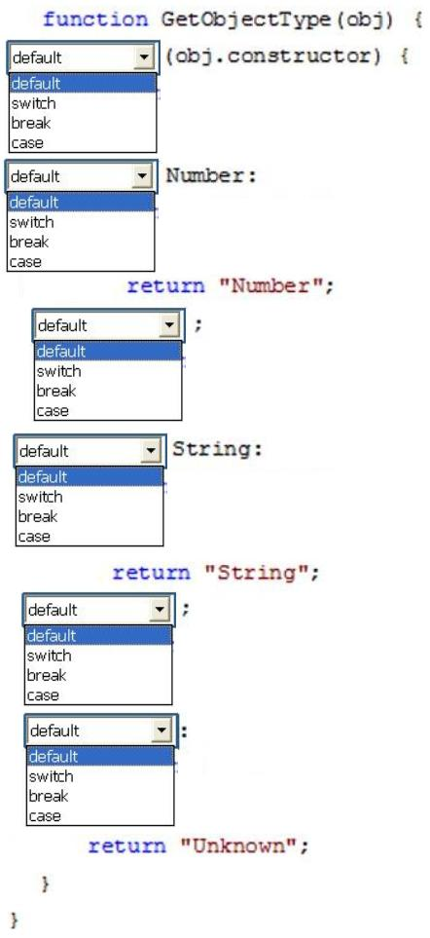You are creating a function by using JavaScript. The function accepts an object as the  
parameter and returns a string that identifies the data type of the object.  
You have the following requirements:  
? The function must return "Number" if the object is a number.  
? The function must return "String" if the object is a string.  
? The function must return "Unknown" if the object is neither a number nor a string.  
You need to implement the function to meet the requirements.  
How should you build the code segment? (To answer, select the appropriate options from  
the drop-down lists in the answer area.)

You are developing an HTML5 web application for displaying encyclopedia entries.  
Each encyclopedia entry has an associated image that is referred to in the entry.  
You need to display the image by using the correct semantic markup.  
What should you do? (To answer, select the appropriate options from the drop-down list in  
the answer area.)

